

**WEBINAR ON NEW KCC**

**STATE BANK INSTITUTE OF RURAL BANKING, HYDERABAD**

**(ISO 9001:2015 CERTIFIED INSTITUTE)**

For more information contact: Ms. Neelam Upadhyay at9619885130 or email to n.upadhyay@sbi.co.in

**THE PROGRAMME:**

* Popularly known as crop loan, Kisan Credit Card (KCC) is the most important Agri-loan product. It is meant for production of crops by providing timely and adequate credit to the farmer community. The KCC occupies major chunk of Agri loan portfolio for the Banks.
* This programme imparts the necessary knowledge among the operating functionaries of the Banks- PSBs/Pvt. Sector Banks/RRBs, by providing the necessary inputs and skills for financing KCC.

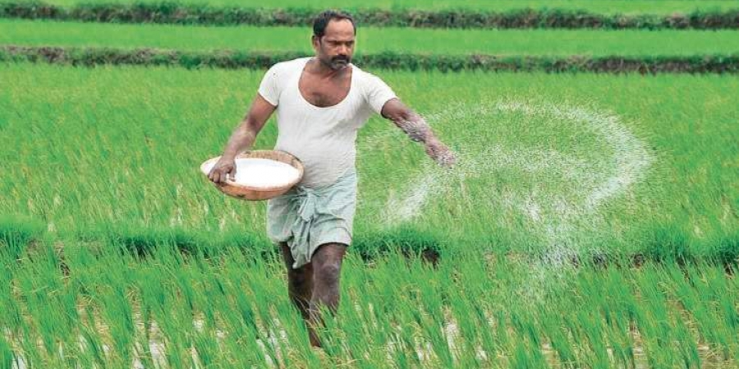

**COURSE CONTENT:**

Pre-sanction visits, post-sanction follow-up, Sanction process, Documentation, Charge creation etc.

**TARGET GROUPS** :

Branch functionaries including Credit Officials of all Banks / Financial Institutions.

**WORLD-CLASS LEARNING & RESEARCH:**

SBIRB is an Apex Training Institute of **State Bank Group.** It is one of the premier institutes of the country catering to the training needs of Agriculture, Rural Banking and Financial Inclusion. What makes the programmes at SBIRB unique is that the training is imparted by an elite group of experienced practicing bankers with excellent academic background.

**OUR OBJECTIVES:**

* To equip the bankers with requisite skill and knowledge.
* To provide orientation required for rural banking.
* To sensitize the bankers to the rural environment.

**OUR FACULTY**

* Experienced bank officials in Senior Management Grade.
* Having technical expertise & with academic excellence
* Drawn from across the country having varied experience and in-depth knowledge.
* International exposure