

**Train the Trainer programme for Business Correspondents**

**STATE BANK INSTITUTE OF RURAL BANKING, HYDERABAD**

**(ISO 9001:2015 CERTIFIED INSTITUTE)**

**THE PROGRAMME:**

* At present, BC/CSP channel plays major role in ‘Financial Inclusion’, the noble objective of the Government of India. BC/CSP channel provides access to the banking products and services at the doorstep of the weaker sections of the society. As this is an outsourced activity, Business Correspondents must be aware of the latest changes in the area.
* This programme imparts the necessary inputs with regard to different aspects of the functioning of CSPs to safeguard the interests of the Business Correspondents as well as the Bank.

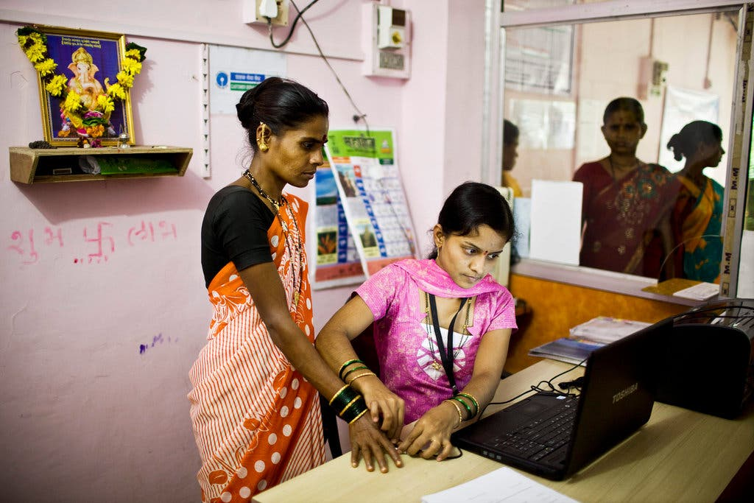

**COURSE CONTENT:**

Various aspects of kiosk banking, product knowledge, periodical checks for constant monitoring of CSPs.

**TARGET GROUP:**

Business correspondents

**WORLD-CLASS LEARNING & RESEARCH:**

SBIRB is an Apex Training Institute of **State Bank Group.** It is one of the premier institutes of the country catering to the training needs of Agriculture, Rural Banking and Financial Inclusion. What makes the programmes at SBIRB unique is that the training is imparted by an elite group of experienced practicing bankers with excellent academic background.

**OUR OBJECTIVES:**

* To equip the bankers with requisite skill and knowledge.
* To provide orientation required for rural banking.
* To sensitize the bankers to the rural environment.

**OUR FACULTY**

* Experienced bank officials in Senior Management Grade.
* Having technical expertise & with academic excellence
* Drawn from across the country having varied experience and in-depth knowledge.
* International exposure

For more information contact: Shri Diwakar Jha at 9471155227 or email to diwakar.jha@sbi.co.in